- Enter the Item List View

- Double click an item on the list to enter the item properties screen

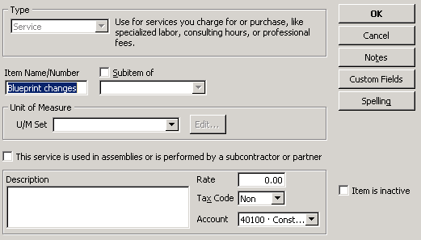

- Press on the Custom Fields button and the Custom Fields screen will open
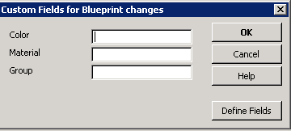

- Press on Define Fields the ‘Set up Custom Fields for Items’ window will open
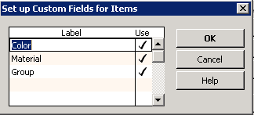

- Add a new Label, and press the Use to mark it with a Checkbox
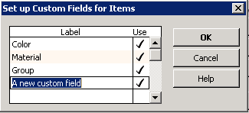

- Add the new custom fields into your item list view. Right click the list and choose ‘Customize Columns’
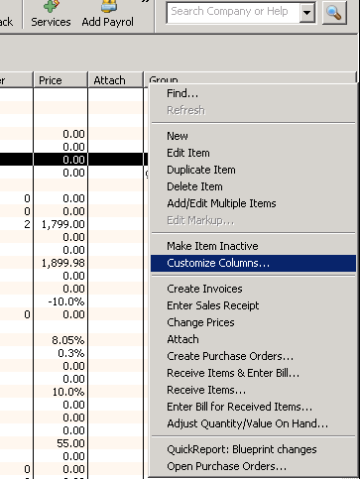

- Find your new added Custom Field and Add it to the chosen Columns

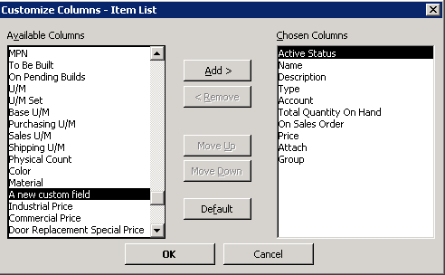
- It is recommended to use the ‘Add/Edit Multiple Item’ from the Right Click menu to add additional data in batch, instead of one by one.
